Page 1
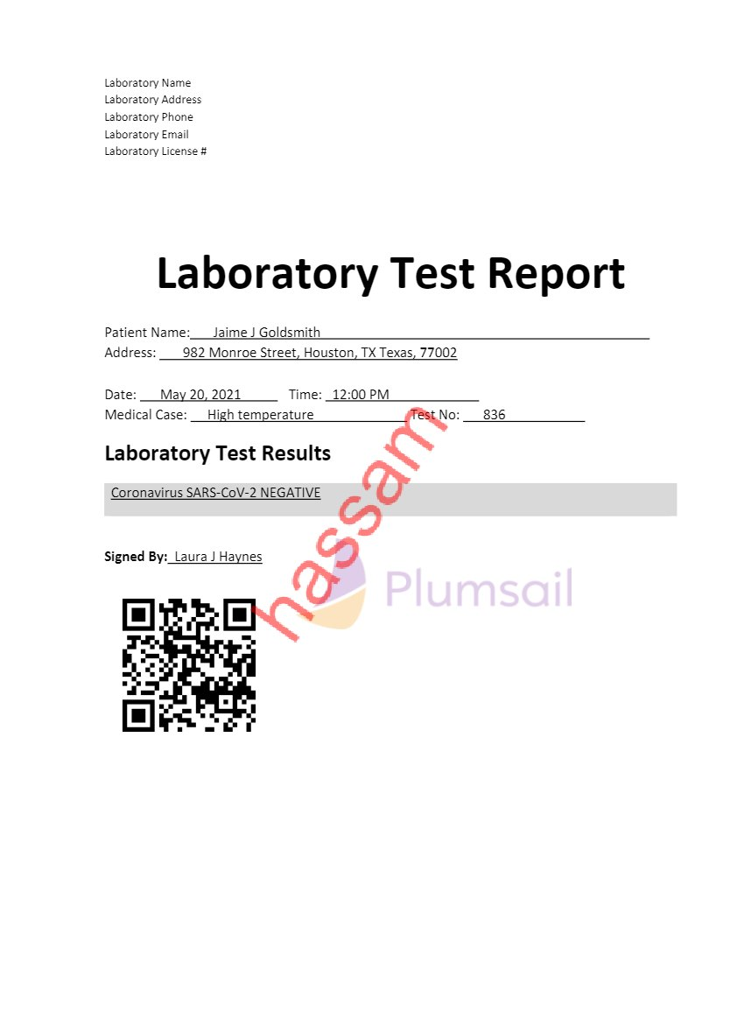
Laboratory Name
Laboratory Address
Laboratory Phone
Laboratory Email
Laboratory License #
Laboratory Test Report
Patient Name: Jaime J Goldsmith 1
Address: 982 Monroe Street, Houston, TX Texas, 77002
1
Date: May 20, 2021 1Time: 12:00 PM 1
Medical Case: High temperature Test No: 836 1
Laboratory Test Results
Coronavirus SARS-CoV-2 NEGATIVE
Signed By: Laura J Haynes

